Offline Rendering

📘 Definition
# Source: AI Source: Provided by: [Data Path: Persons Table -> ID Column: 1, Name_En Column: Motasem Essam] -> From: [ChatGPT] on [5/2/2026]
Offline Rendering is a type of rendering where images or animations are calculated in advance (not in real time) to produce very high-quality and realistic visuals.
It is also called pre-rendering because the final image is generated after a long processing time.

🖥️ How offline rendering works
# Source: AI Source: Provided by: [Data Path: Persons Table -> ID Column: 1, Name_En Column: Motasem Essam] -> From: [ChatGPT] on [5/2/2026]
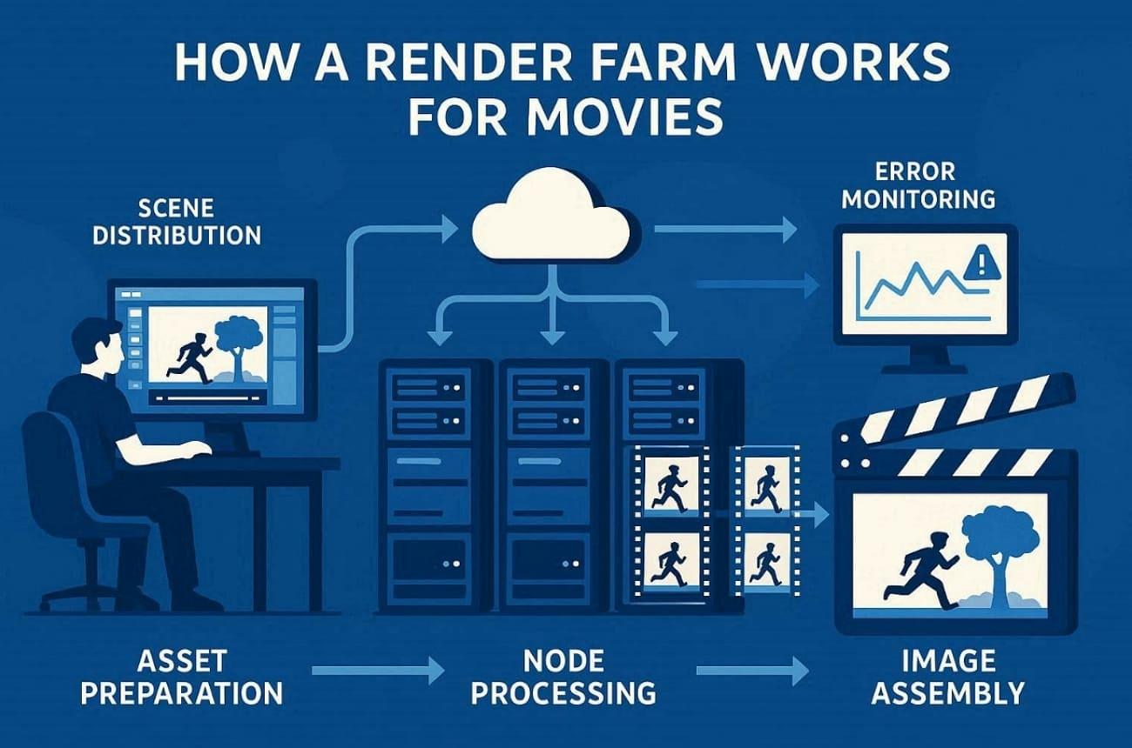
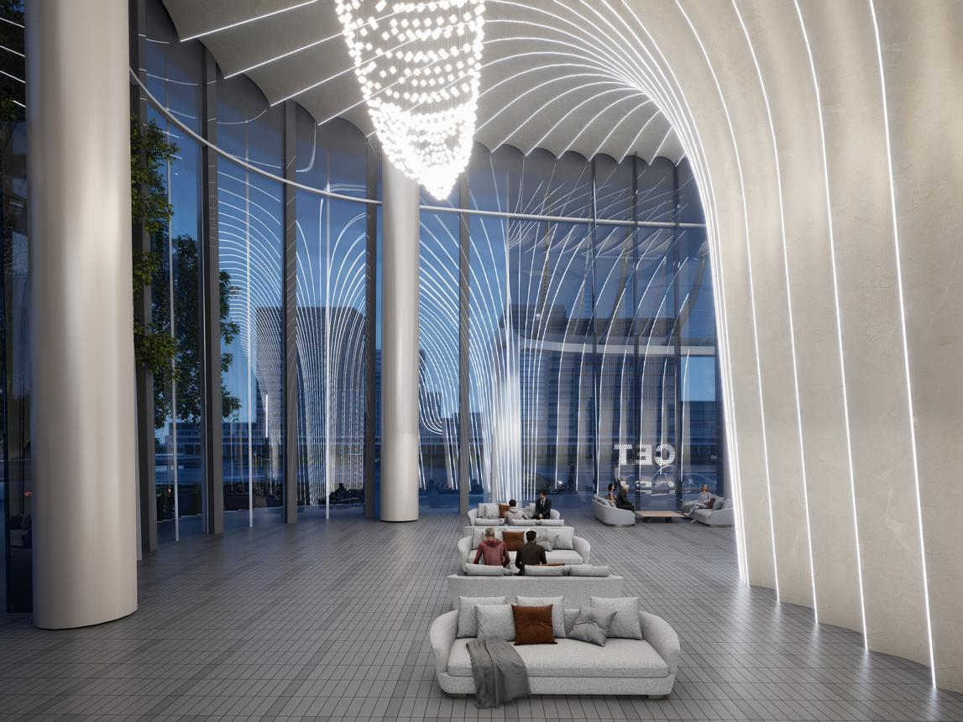
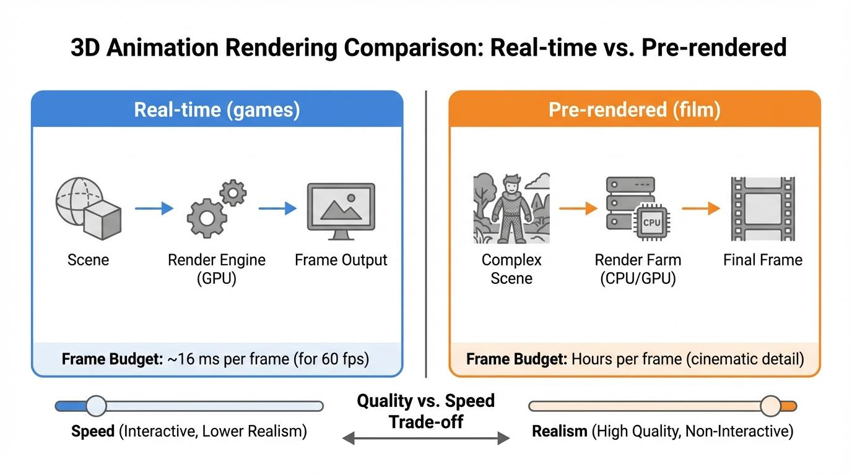
- The scene is sent to a powerful computer system (render farm)
- It calculates every detail carefully (lighting, shadows, reflections, physics)
- Each frame can take seconds, minutes, or hours
- The result is a high-quality final image or animation

🧠 Simple example
# Source: AI Source: Provided by: [Data Path: Persons Table -> ID Column: 1, Name_En Column: Motasem Essam] -> From: [ChatGPT] on [5/2/2026]
Think of:
- 🎬 A movie animation scene (like Pixar films)
- 🖼️ A high-quality 3D architectural image
- 🎨 A detailed CGI poster
These are not generated instantly—they are carefully prepared beforehand.

🎬 Where offline rendering is used
# Source: AI Source: Provided by: [Data Path: Persons Table -> ID Column: 1, Name_En Column: Motasem Essam] -> From: [ChatGPT] on [5/2/2026]
- 🎬 Movies and animated films
- 🧑‍🎨 High-quality CGI production
- 🏗️ Architecture and product visualization
- 📢 Advertising and visual effects (VFX)

⚙️ Key features
# Source: AI Source: Provided by: [Data Path: Persons Table -> ID Column: 1, Name_En Column: Motasem Essam] -> From: [ChatGPT] on [5/2/2026]
- 🐢 Slow rendering (high processing time)
- 🌟 Very high quality and realism
- 💡 Uses advanced lighting (global illumination, ray tracing)
- 🖥️ Often uses powerful render farms

🚀 In short:
# Source: AI Source: Provided by: [Data Path: Persons Table -> ID Column: 1, Name_En Column: Motasem Essam] -> From: [ChatGPT] on [5/2/2026]
Offline rendering = slow, high-quality rendering used to create realistic images and animations for movies, CGI, and professional graphics.

